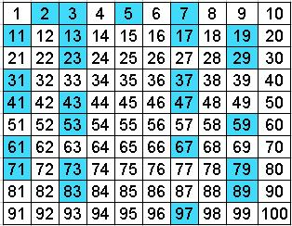

Prime Numbers

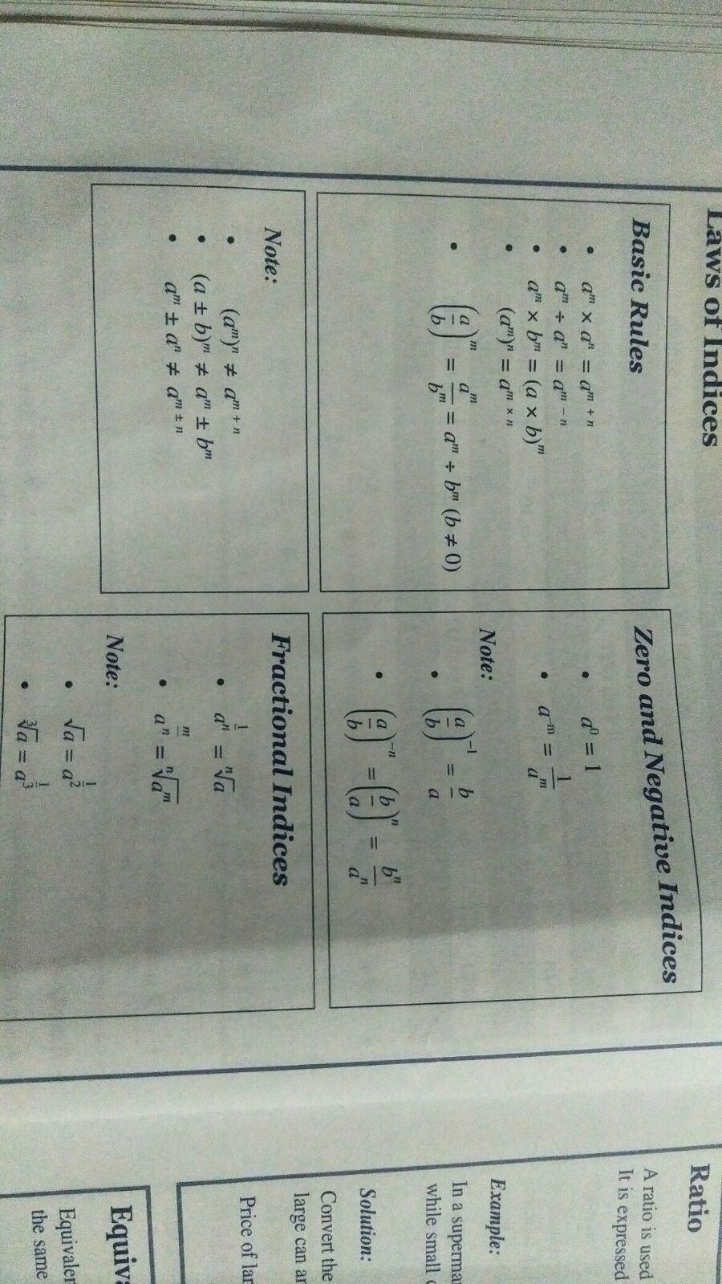



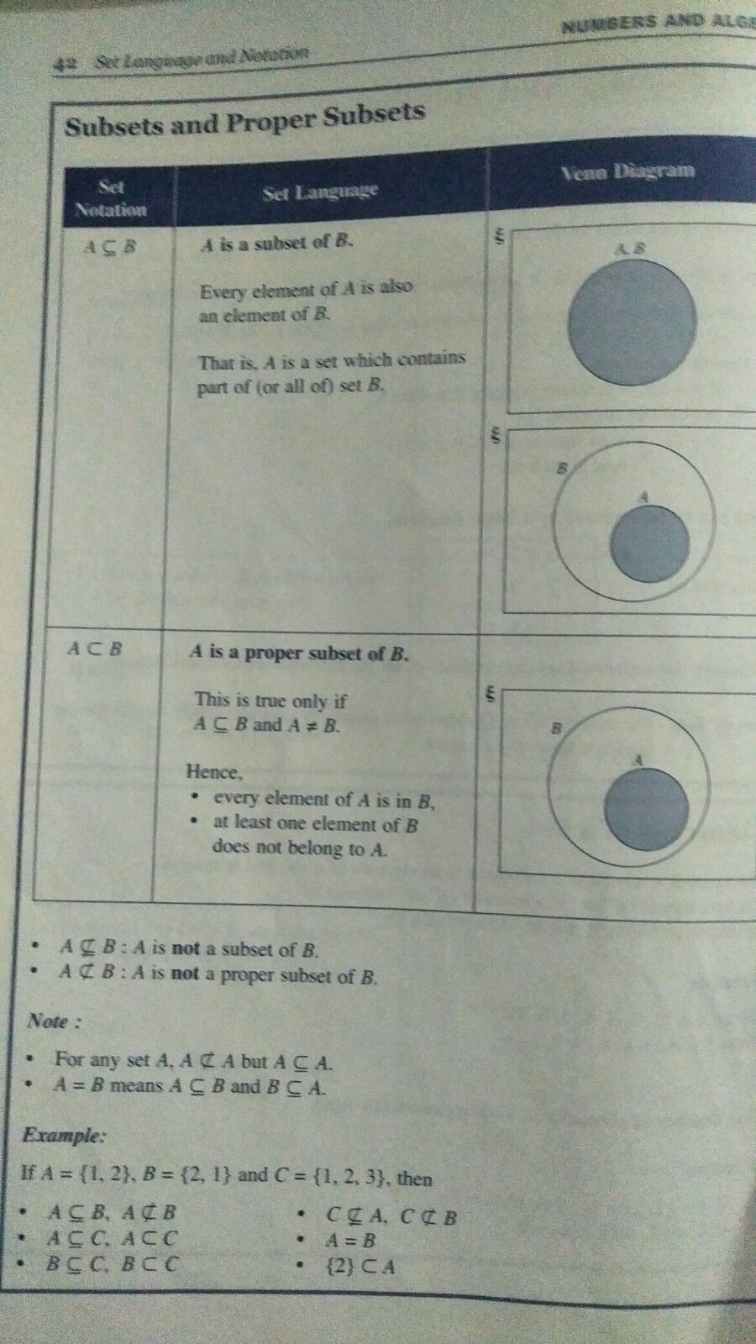

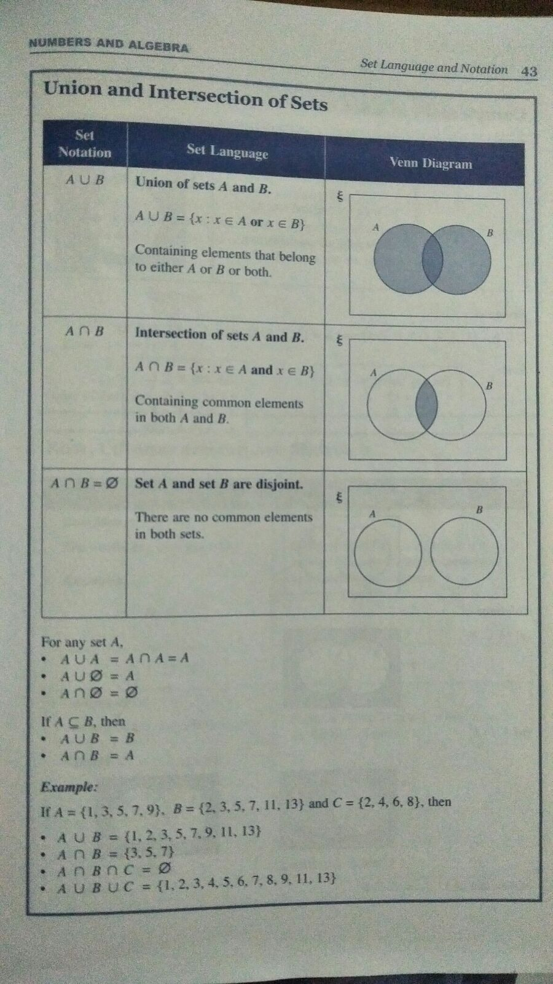

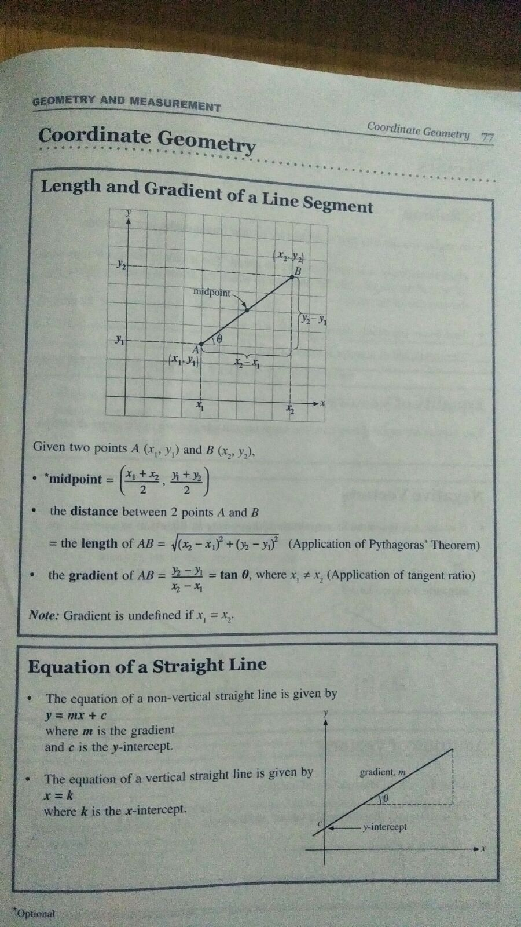

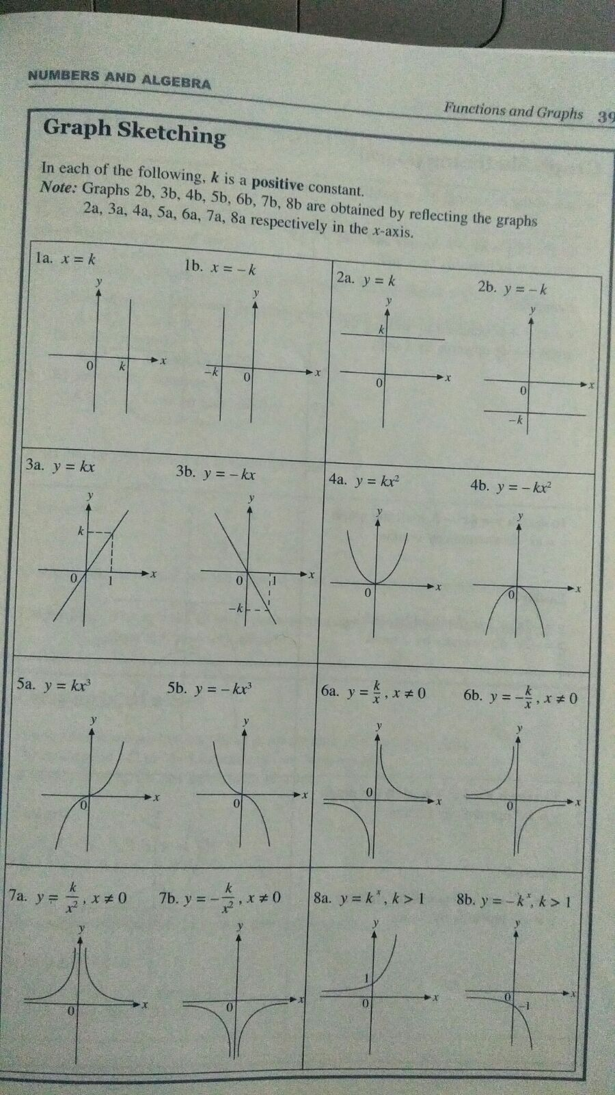



**Completing the square method:**

The quadratic equation  can be expressed as follows:

,

This form is also known as **completed the square** form.

We can make use of this form to determine the minimum /maximum point of a quadratic curve.

* When *a* is positive, the term  will always be positive for all real values of *x* except for  where  will become zero.

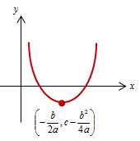

Therefore, the minimum value of  when .

The minimum point is .

* When *a* is negative, the term  will always be negative for all real values of *x* except for  where  will become zero.

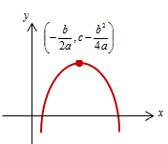

Therefore, the maximum value of  when .

The maximum point is .

Example:

Given that *a* = -2, *b* = 4 and *c* = 1, the equation  can be expressed as:



 ------------------------------------------------ (1)

We can now use equation (1) to find:

1. Maximum value of *y*:

From equation (1), the term  will always be negative for all real values of *x* except for *x* = 1 where the term will become zero. Therefore the maximum value of *y* is 3 when *x* = 1.

1. Values of *x* when *y* = 0:

Let *y* = 0 for equation (1),









 or 

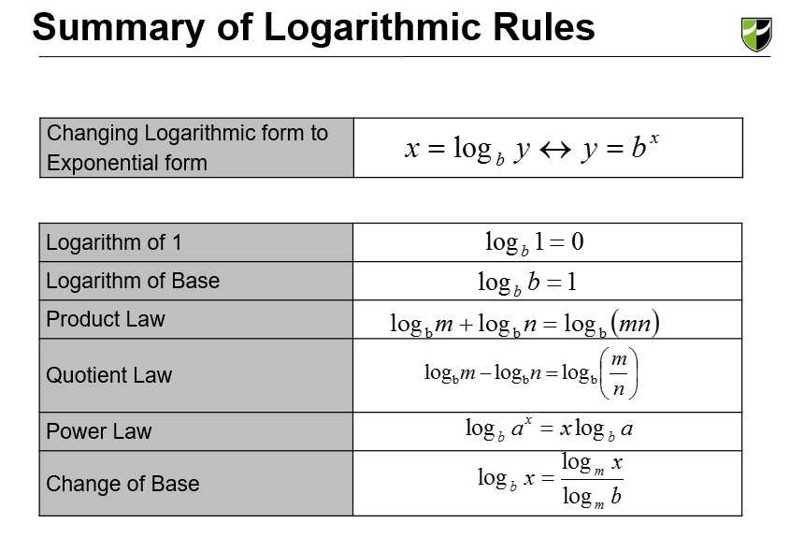

Speed = Distance/Time

Velocity = Displacement/time

Instant. Velocity = Gradient of Displacement Time Graph

Average Velocity= Total Displacement/Time

Velocity Time Graph – Displacement= Area under graph



Probability

**Given That - Denominator**

